Lab 3

Name: Harshil Patel

Id:32

I have created application in which student preparing for TOFEL can get help for there speaking section.

Main page

In this user will have a paragraph to read.then user can click on mic and and speak the same paragraph after that user can save there voice in text format in sqlite DB.

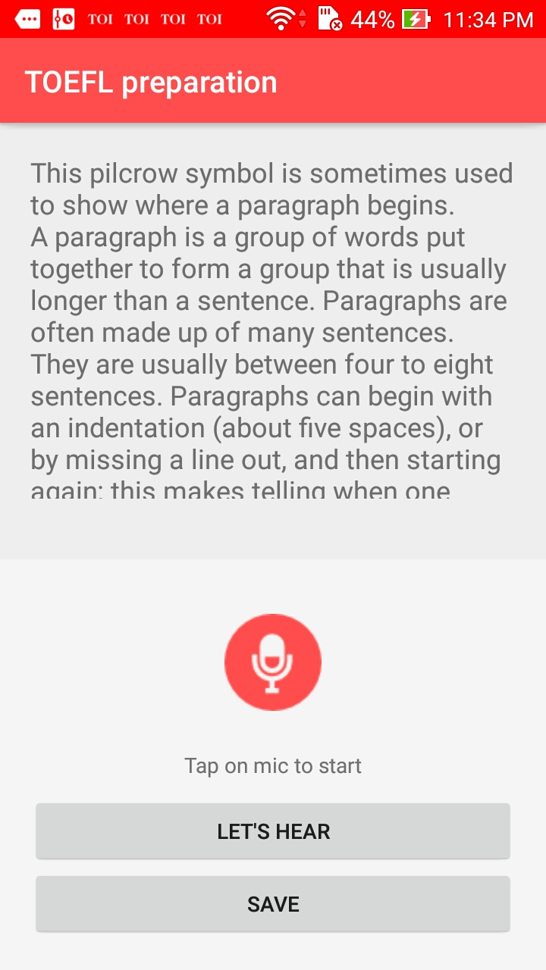

Database page

In this page user can select the paragraph that the want to practice as well as they can see there history they have tried.

